3R Flexible Robot Arm

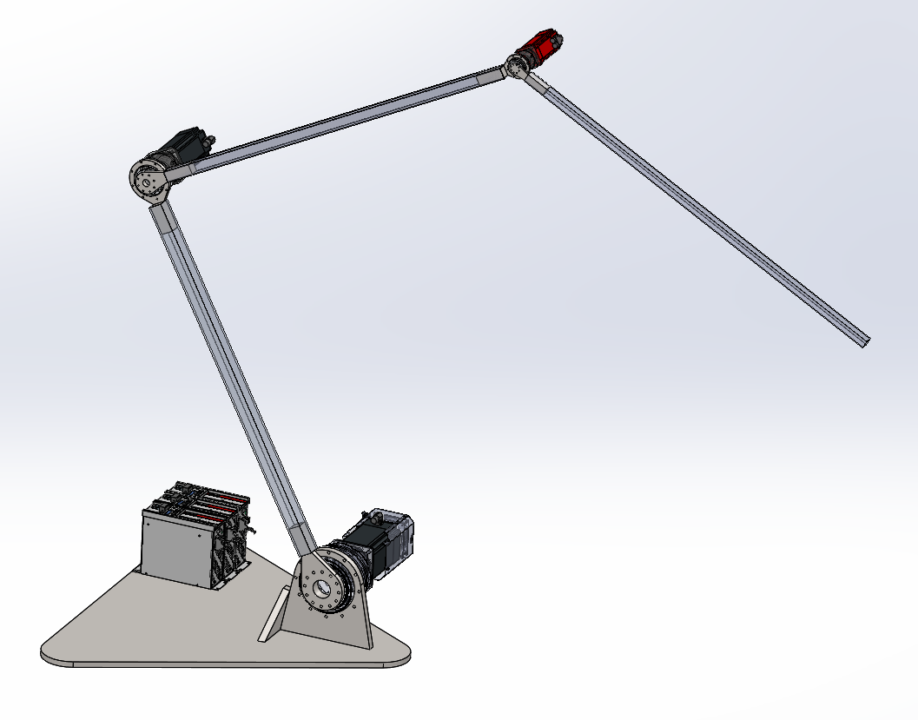

# Joint 1

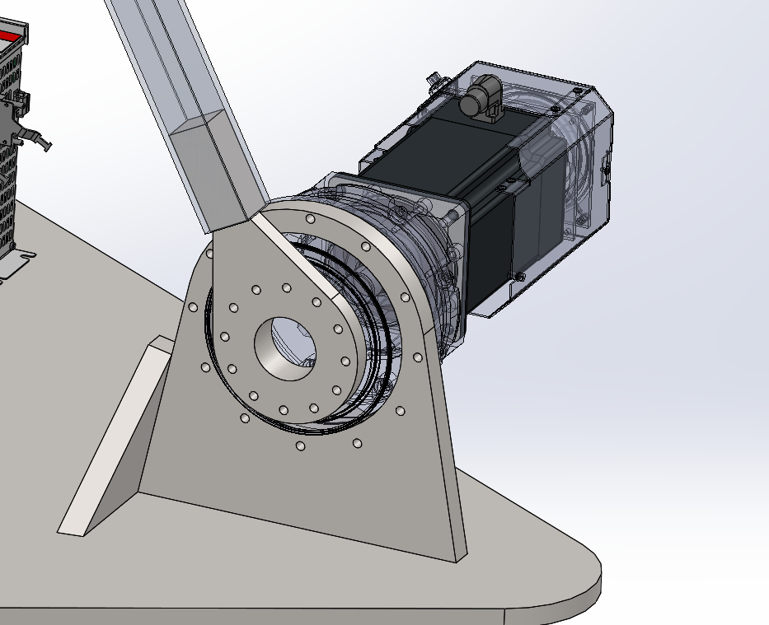

# Joint 2

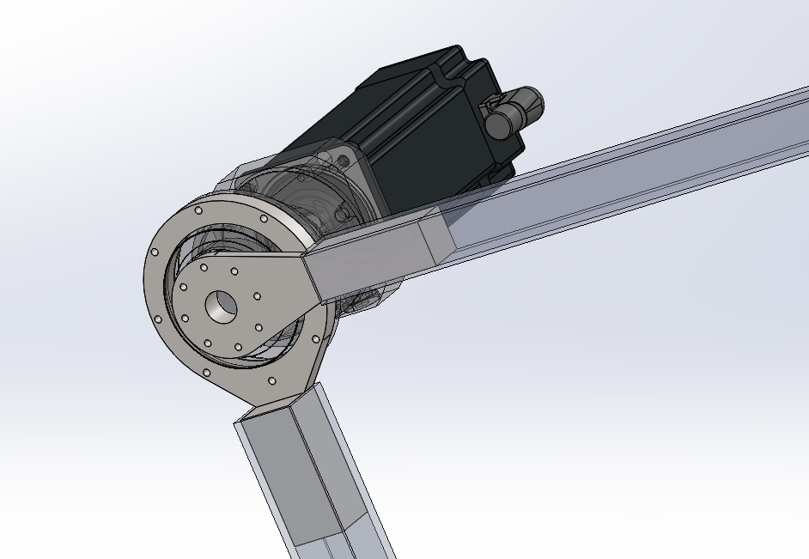

# Joint 3

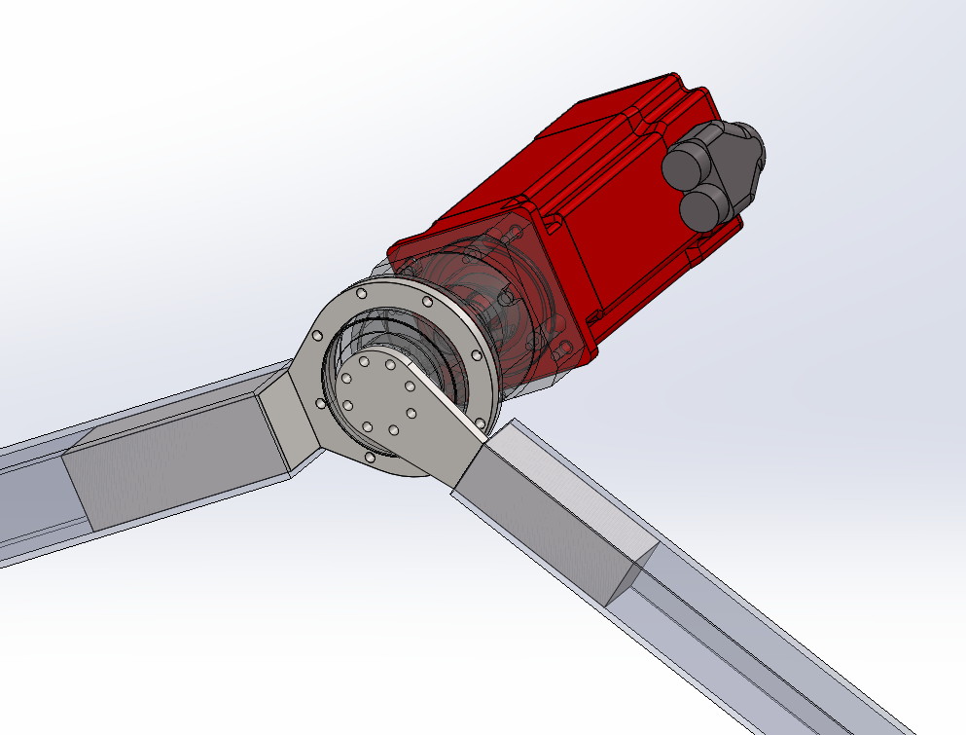

# Mechanical Tolerances between Parts

|  |  |  |  |
| --- | --- | --- | --- |
| Joint ID | Part A | Part B | Tolerance |
| 1 | 1A | AG2400-TP110S | H7 |
| 1 | AG2400-TP110S | 1B | H7 |
| 2 | 2A | AG2400-TP025S | H7 |
| 2 | AG2400-TP025S | 2B | H7 |
| 3 | 3A | AG2400-TP004S | H7 |
| 3 | AG2400-TP004S | 3B | H7 |

# Joint1 - AG2400-TP110S

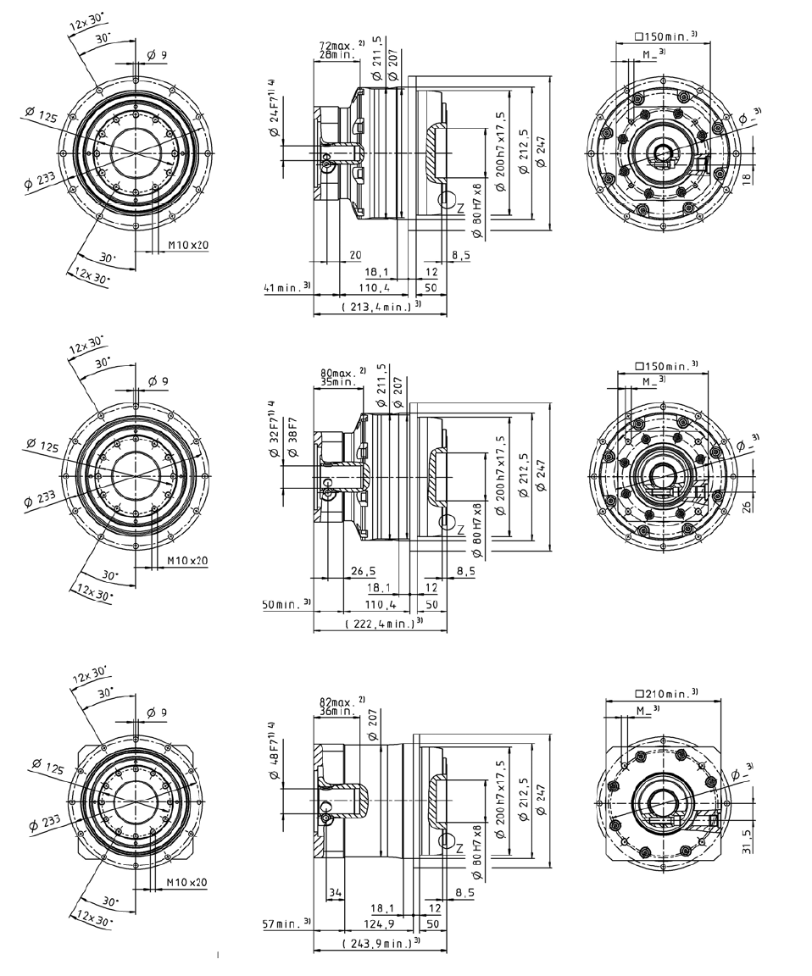

# Joint2 - AG2400-TP025S

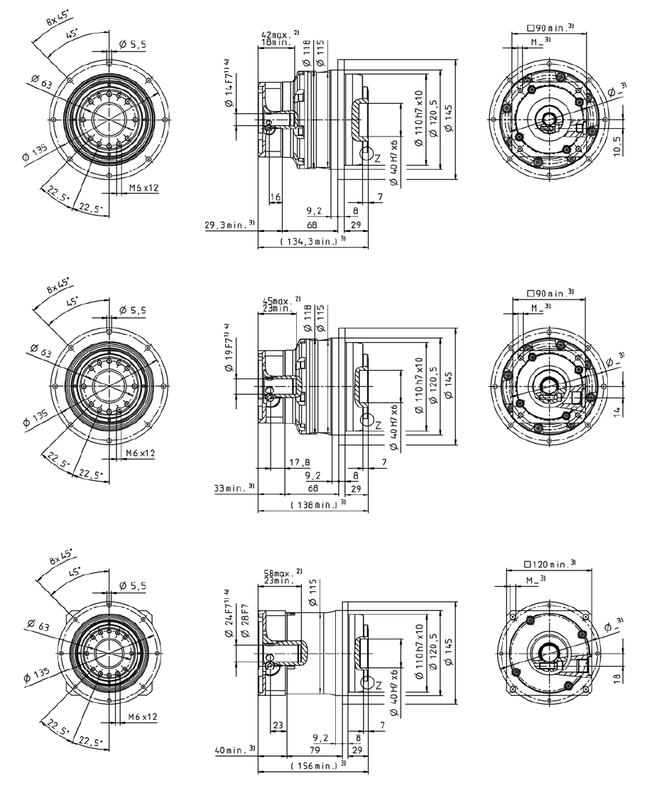

# Joint3 - AG2400-TP004S

